2017 Three rivers tesol annual conference

The Highly-Qualified Teacher:
Core Practices for ESL Education

OCT. 21, 2017， 8:30 – 3:30

duquesne University,
600 Forbes Avenue, Pittsburgh, PA 15282

CONFERENCE THEME
The Highly-Qualified Teacher:
Core Practices for ESL Education

Conference Schedule
8: 30-9:00 Breakfast/Check-in
9:00-10:30 Breakout Sessions
10:40-11:20 Interest Sections
11:30-12:30 Plenary Talk
12:30-1:30 Lunch
1:40-3:10 Breakout Sessions/Posters/Panel Discussion
3:15-3:30 Three Rivers TESOL Update

Three Rivers TESOL
Three Rivers TESOL serves the Central and Western Pennsylvania area and is an affiliate of TESOL.

The Mission of Three Rivers TESOL:
- To stimulate the professional development of the teachers of ESOL within the area served by the association: central and western Pennsylvania;
- To encourage and improve the teaching of ESOL within this area;
- To establish national contacts through affiliation with TESOL;
- To provide opportunities for group study and discussion of problems which confront ESL teachers of this area.

Three Rivers TESOL Conference:

The annual Three Rivers TESOL conference offers English language teaching (ELT) professionals and students in and around central and western Pennsylvania the opportunity to discuss issues facing the local ELT communities, to exchange ideas and practices, to network with other local ELT professionals, and to enhance their knowledge of a vast range of ELT content areas. The Three Rivers TESOL Conference complements the TESOL International Convention and Expo by focusing on issues that affect the local communities that Three Rivers TESOL serves.

Three Rivers TESOL 2017 Board Members and Conference Committee:

 | Name | Affiliation | Contact
President | Ying Zhang | Robert Morris University | president@threeriverstesol.org
Vice President | Jialei Jiang | Indiana University of Pennsylvania | vp@threeriverstesol.org
Past President | Seungku "Steve" Park | Slippery Rock University | pastpres@threeriverstesol.org
Secretary | Greg Mizera | University of Pittsburgh | secretary@threeriverstesol.org
Treasurer | Michael Burke | Duquesne University | treasurer@threeriverstesol.org
Webmaster | Bill Price | University of Pittsburgh | webmaster@threeriverstesol.org

History of Three Rivers TESOL
Our organization goes back 28 years, to the first inaugural business meeting of interested ESL professionals at Point Park College on Nov. 17, 1989. About 25 people attended, representing schools and programs in the region. The draft constitution was discussed and accepted with some amendments. After discussion, the name Three Rivers TESOL was chosen, with the words “Central and Western Pennsylvania and West Virginia” added to announcements and correspondence whenever possible to show the geographic regions served by the association.

The first officers of Three Rivers TESOL were Kim Bell of Point Park College as President, Dan Tannacito of Indiana University as Vice president, Lionel Menasche of the University of Pittsburgh as Secretary and Missy Butler of Carnegie Mellon University as Treasurer. The membership dues were set at $15 for regular members and $5 for students. The organization sent newsletters to its members and offered a fall conference and a spring meeting. The first ESL Fall conference was held at Indiana University of Pennsylvania on Nov. 10, 1990 with Plenary Speaker Alister Cumming.
Twenty-eight years later, Three Rivers TESOL continues to serve Western Pennsylvania, drawing ESL professionals from post-secondary, secondary and family literacy organizations. Institutions hosting our events have included Carnegie Mellon University, the University of Pittsburgh, Indiana University of Pennsylvania, Point Park University, Clarion University, the University of West Virginia, La Roche College, Chatham University, Pittsburgh Public Schools, Franklin Regional School District, and the Greater Pittsburgh Literacy Council. In addition to the fall conference, an annual spring meeting offers members the latest in research and methodology, and updates on the local ESL scene. Interest groups for IEP Administrators, adult education, higher education, teacher education, K-12 Teachers, and CALL have been established. In 2003, we put our newsletters online and in 2007 we added the position of Webmaster to our board of directors. Our website, threeriverstesol.org, offers links to International TESOL, to which we are an affiliate, and to our institutional members. Our membership dues are still reasonable, at $30 for regular members and $15 for students.
Each year, we seek ESL professionals to continue promoting excellence in ESL education, professional development and service through Three Rivers TESOL. Whether you are a teacher in a public school, a tutor of refugees, an instructor in a university ESL Program, a researcher of language education in ESL settings, or an EFL teacher visiting Pittsburgh for educational or professional purposes, you are welcome. Your participation makes our Three Rivers TESOL affiliate the professional home base for ESL educators in our region.

PLENARY TALK
Identifying and Using Core Practices for Students Learning English
Dr. Megan Madigan Peercy

Abstract: In this presentation, Dr. Megan Madigan Peercy will discuss one of the field’s central conversations about teaching students learning English, drawing upon the last four years of research she has conducted. She will examine and discuss the following key questions:
- What are core practices for teaching?
- How do core practices for teaching inform the preparation and practice of teachers across contexts?
- What core practices are specific to teaching students learning English?
- How are these practices identified and how can teachers and students benefit from their use?
She will also share examples from ESL teachers’ practice to illustrate the use of core practices in action.

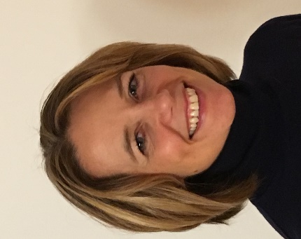
Presenter: Dr. Megan Madigan Peercy is an Associate Professor in Applied Linguistics & Language Education (ALLE) in the Department of Teaching and Learning, Policy and Leadership.
Her research focuses on the preparation and development of teachers throughout their careers, as they work with linguistically and culturally diverse learners. Dr. Peercy’s recent work examines the theory-practice relationship in second language teacher education, the identification and enactment of practice-based approaches for teaching language learners, and teacher collaborative relationships and learning as they work with language learners. Her recent research appears in venues such as TESOL Journal, Teaching and Teacher Education, Professional Development in Education, Teacher Education Quarterly, and Teachers and Teaching: Theory and Practice. She and her colleague Dr. Judy Sharkey (University of New Hampshire) have a forthcoming edited book with Emerald Press entitled Self-study of language and literacy teacher education practices across culturally and linguistically diverse contexts. Dr. Peercy has experience as an ESOL and Spanish teacher across a variety of ages and contexts, ranging from pre-K through adults.

Institutional Members
Institutional Members are organizations and programs that have paid the institutional
membership fee of $150. Employees working for Institutional Members can join Three
Rivers TESOL at a reduced rate. Institutional Members may have their website listed on
the Three Rivers TESOL website, register their employees through an easy process,
and request a table to display information about their organization or program at the
Three Rivers TESOL Fall Conference. Thank you for your support!

Chatham University English Language Program
Website: www.chatham.edu/elp

Duquesne English as a Second Language Program
Website: www.duq.edu/esl

Gannon University English Language and Global Training
Website: http://www.gannon.edu/Admissions/International-Admissions/English-Language-and-Global-Training/
La Roche English as a Second Language Program
Website: http://laroche.edu/esl

University of Pittsburgh English Language Institute
Website: http://www.eli.pitt.edu/index.html

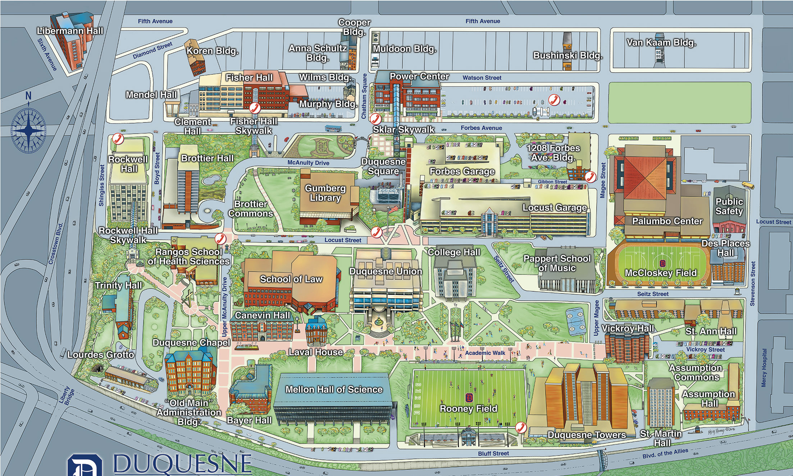
On-campus Dinning:
Duquesne Union:
The Incline – student dining hall on the 1st floor of the Duquesne Union.
Burgers, chicken sandwiches, salad wraps, pizza
Starbuck’s – 2nd floor of Duquesne Union
Java City – ground floor of Rockwell Hall
Sandwiches, light snacks, desserts, coffee
Hogan Dining Center – student dining hall on the 2nd floor of Towers Hall

Parking:
Please park in the Forbes garage (the entrance is on the Forbes Ave.). The weekend rate is $6/day. Pay stations are located on the 1st and 8th floors of the Forbes. Once you park, take the elevator to the 8th floor. Exit the garage and walk straight and you will see the college hall on your left side, besides the Duquesne union.

Off-Campus Dinning:
The Red Ring – 1015 Forbes Ave. (American food, wraps, burgers, bar)
T.G.I.Fridays – 1027 Fifth Ave. (Casual American food, sports bar)
Milano’s pizza – 1304 Fifth Ave. (Pizza, Wings, Subs, Gyros, bar)
China Wok – 1201 Fifth Ave. Typical Chinese food, good lunch specials
Subway – 1035 Fifth Ave.
Buford’s Kitchen – 1014 Fifth Ave.

Forbes Garage
College Hall
Forbes Avenue
Fifth Avenue

Conference Schedule at a Glance
Time/Room | CH 104  (Lecture Hall) | CH105  (Lecture Hall) | CH449 (classroom) | CH447  (Classroom) | CH548  (Classroom) | CH553  (Classroom)
8:30-9:00 | Check-in (In CH 104) & Breakfast
9:00-9:40 | Publishers & Institutional Members (Hallway of the 1st floor) | Strategies for Overcoming Fossilization of ESL Students in IEP | Reflection as learning | Taking it from the Streets: Kinesthetic Projects for Advanced Students  (Canceled) | Intersemiotic Translation: developing reading and writing skills and empowering L2 learners | Full-class review games using students' smartphones
9:50-10:30 |  | Islamic Music for Teachers Teaching Muslim Students | Hiring of Nonnative English-Speaking Teachers | IEP Administration Strategies for Private Institutions/Sectors in China | Teaching for Transfer | Methodology to Writing Competent, Independent Expository Essays
10:40-11:20  (Interest Sections) |  | IEP/HE | PK-12 | TE | CALL | AE
11:30-12:30 | Plenary (In CH 105)
12:30-1:30 | Lunch (Not included)
1:40-2:00 | Posters (Hallway of the 4th floor) | Panel Discussion: Supporting Refugees and Immigrants in Pittsburgh  (2:50-3:10) | Before-reading strategies for English Language Learners | IEP Students Take Debate Cues from Hamilton: An American Musical | Writing: Transparent Processes Towards Target Products
2:10-2:50 |  |  | The negotiation of voice in Academic Writing by multilingual writers | YouTubers are the Best English Teachers | Path to College Success with Listening and Speaking Skills | Is "nativeness" a preference or an absolute requirement in the ESL job posts? A problematization of the notion
2:50-3:15 | Break
3:15-3:30 | Three Rivers TESOL Update (CH 105)
Presentation Information
9:00-9:40 SESSIONS
CH 105 | Strategies for Overcoming Fossilization of ESL Students in IEP  Brian P Burke  University of Pittsburgh Johnstown  bpb31@pitt.edu | Practice,  IEP | What can be done with the student who does not progress and matriculate from the IEP? This practice-oriented presentation focuses on the various strategies that the teacher can utilize with students who have become fossilized within the language level. Those strategies discussed are by three tiers: Administration, Teaching, and Tutoring.
CH 449 | Reflection as learning  Virginia Robson  University of Pittsburgh  robson@pitt.edu | Practice,  Higher Education | Reflection is a valuable 21st century skill for students at all levels, and is also a key workplace competency. The presenter will share ways to incorporate written and spoken reflective tasks (including using digital/online tools) which teach students how to confidently and realistically examine their individual academic abilities and performance.
CH 447  (Canceled) | Taking it from the Streets: Kinesthetic Projects for Advanced Students  Christine Ismaeil  Duquesne University  ismaeilc@duq.edu | Practice,  Adult Education | This session will describe two examples of kinesthetic learning, then provide small groups of participants with craft materials and a short reading to “illustrate” and share with the larger group. This presentation is designed to be highly participatory and to enhance instructor’s appreciation for more engaging teaching/learning opportunities.
CH 548 | Intersemiotic Translation: developing reading and writing skills and empowering L2 learners  Ana Sanchez  West Chester University  asanchez@wcupa.edu | Practice,  Higher Education | The presenter shows how intersemiotic translation can empower L2 learners and become a tool to develop reading and writing skills. The L2 learner as translator has a very active, creative and dynamic role as s/he becomes a decision maker in the interpretation and transferring of meaning from the source to the target semiotic mode.
CH 553 | Full-class review games using students' smartphones  Bill Price  University of Pittsburgh  wcp5@pitt.edu | Practice,  CALL | In this practice-oriented presentation, two free smartphone review game websites (Quizlet Live and Kahoot!) will be demonstrated. Participants will have the opportunity to try sample games and learn how to make their own.
9:50-10:30 SESSIONS
CH 105 | Islamic Music for Teachers Teaching Muslim Students  Omar Yacoub  Indiana University of PA  o.a.yacoub@iup.edu | Practice,  Teacher Education | The idea of this proposal is employing Islamic music to help Muslim learners of ESL gain a sensitive ear to recognize intonation, stressed and unstressed syllables. Several albums of Islamic music are spouted fluently which innervate the listening skill when a student plays them.
CH 449 | Hiring of Nonnative English-Speaking Teachers  Marina Razgarina  Chatham University ELP  razgarina@hotmail.com | Discussion,  IEP | The presenter proposes a discussion on challenges of Non-Native English Speaking Teachers within hiring processes in the U.S. Using data, the presenter demonstrates that despite some false perceptions of hiring institutional administration, language learners in Intensive English Instructions do appreciate and value their NNES teachers.
CH 447 | IEP Administration Strategies for Private Institutions/Sectors in China  Jiaqi Huo  Duquesne University  huoj@duq.edu | Practice,  Program Administration | The presenter introduces Intensive English Program administration strategies for private educating sectors in China to improve teaching and enhance program management. Targeting high-school students who plan to study aboard as audience, the presenter demonstrates how to combine their autonomy with strategies in curriculum development, leaning-process management and outcome/educational quality controls.
CH 548 | Teaching for Transfer  Wenqi Cui  Indiana University of PA  w.cui@iup.edu | Research,  Adult Education | The presenter introduces a genre-based pedagogy, Linguistic-Rhetoric Interactionism, which helps first-year L2 students at American universities address linguistic, rhetorical, and genre-bound challenges they confront and improve their writing expertise as well as ability of writing transfer across disciplines.
CH 553 | Methodology to Writing Competent, Independent Expository Essays  Robert Hellstrom  Edinboro University  rhellstrom@edinboro.edu | Practice,  IEP | A practical guide to enable students to produce competent expository essays independently. The guide focuses on organization, ensuring detailed body paragraphs, consistent subjects, and subject/verb agreement.
1:40-3:10 SESSION
CH 105 | Supporting Refugees and Immigrants in Pittsburgh | Panel Discussion | Representatives from local community-based groups serving immigrants and refugees describe their programs and share their insights. What are the challenges of engaging families and youth in the schools and community? What contributions and benefits do the newcomers bring to our region? Amidst a rapidly changing national and regional situation, we consider our roles and responsibilities as language educators.
1:40-2:00 SESSIONS
CH 449 | Before-reading strategies for English Language Learners  Ying Zhang  Robert Morris University  zhang@rmu.edu | Teaching tips,  K-12 | The presenter introduces two before-reading strategies: wall paper and list-group-label to help ESL and/or content area teachers to address the linguistic needs of English Language Learners (ELLs). The audience will participate in the activities to learn how to incorporate them into their daily teaching.
CH 447 | IEP Students Take Debate Cues from Hamilton: An American Musical  Jacqueline Gianico  Penn State University  jmg565@psu.edu | Teaching tips,  IEP | In this teaching tip, the presenter will demonstrate a lesson on debating from an IEP short fiction class. Participants will learn how the “Cabinet Battle” songs from Hamilton can be used as debate models. Materials will be provided for attendees to use or develop their own Hamilton debate lessons.
CH 548 | Writing: Transparent Processes Towards Target Products  Lilia Savova  Indiana University of PA  lsavova@iup.edu | Teaching tips,  IEP | Have you wondered how a student paper was composed and how you might help that student since drafts as we know them provide limited transparency. This presentation demonstrates how using Noodletools, an all-in-one writing program, does just that by guaranteeing transparency at all stages of writing (bibliography, note cards, outline, paper).
2:10-2:50 SESSIONS
CH 449 | The negotiation of voice in Academic Writing by multilingual writers  Inggrit O. Tanasale  i.o.tanasale@iup.edu  Wenqi Cui  w.cui@iup.edu  Indiana University of PA | Research,  Adult Education | Mainstream academic writing discourse at universities in the U.S. can be challenging for international students who bring culturally and socially different normative literacies. This study showcases the potentials that multilingual writers creatively transfer and use their social, cultural, and academic knowledge to negotiate and construct their voice in their academic writings.
CH 447 | YouTubers are the Best English Teachers  Omar Yacoub  Indiana University of PA  o.a.yacoub@iup.edu | Practice,  Adult Education | YouTube has been a great source of learning since several channels have started uploading tutorial lessons. However, the target of this proposal is not the tutorial videos, it is the daily vlogs uploaded by young men and women which are very beneficial for learning English.
CH 548 | Path to College Success with Listening and Speaking Skills  Soyoung Burke  Saint Francis University  sburke@francis.edu | Practice,  IEP | This presentation offers ideas on course activities and curricular improvement for academic success of advanced ESL students in university classroom. Learning about the course objectives, outcomes, assessments, activities, and course evaluations will be valuable for ESL and college curriculum development.
CH 553 | Is "nativeness" a preference or an absolute requirement in the ESL job posts? A problematization of the notion  Mohamed Yacoub  Indiana University of PA  taha.mohamaad@gmail.com | Practice,  IEP | This mixed methods paper investigates the issue of "nativeness" in the job ads in different job-search websites. It was found that "nativeness" is a quality that is either preferred (21%) or required (79%). The notion is discussed and problematized.

Posters
1:40-2:50 4th floor Hallway
Literature as a source for students' long-term life skills  Said Rashid Al Harthy  Indiana University of Pennsylvania  lightfrompast@hotmail.com | Higher Education | The perceptions of 26 graduate students in English studies answered the research question: What long-term life skill values from reading literary texts are reported by readers of literature? The study indicated that the participants had positive and strong perceptions that reading literacy contributes building and developing 14 life skills.
The Big Read: Integrating English Language Learners into Campus Community  Duquesne University  Terra Merkey  merkeyt@duq.edu  Kathy Lipecky  lipeckyf@duq.edu | Higher Education | The presenters will illustrate how Duquesne University inspired dialogue between English Language Learners (ELLs) and the mainstream campus community through a Big Read program hosted by Gumberg Library.
Portraying literacy concepts with arts-based visual aid  Michael Hartman  Indiana University of Pennsylvania  jxjl@iup.edu | Adult Education | The presenter will introduce the Castle of Literacies, a 3-D, arts-based visual aid depicting, through various displays, concepts covered during the presenter’s L2 Literacy course, in a manner that cannot be done with a traditional academic essay, and explain how to incorporate it into a literacy curriculum.
The weak output of English students in Saudi schools  Norah Rayyani  Indiana University of Pennsylvania | Higher Education | Having English language Saudi students at a high or low level depends mainly on four significant elements. These factors are presented in the English language method of teaching, the content of English course books, the formal assessment method, and the age which Saudi students start studying English.
Using digital technologies in teaching English for occupational purposes to agriculture students  Natalia Ziablova  Indiana University of Pennsylvania  wmyx@iup.edu | Adult Education | This poster enables participants to learn how digital technologies can be applied in teaching English for occupational purposes (EOP) to agriculture students in order to foster learning process and get valuable outcomes both linguistic and content related. It demonstrates a number of examples where computer applications are used in an “English for Agriculture” course units to teach new material, practice it and assess students.
Learning Vocabulary by Using Modern Technology  Miad Alazmi  Indiana University of Pennsylvania | Higher Education | This poster discusses how using modern technology going to help international student to learn and pronounce vocabulary very fast.
Benefits of Using ICT in ESL Classes  Meshal Ibrahim  Indiana University of Pennsylvania | IEP | This presentation explains how the technical developments taking place in various aspects of life have revolutionized English language teaching and learning in the last decade. The presenter will discuss some potential benefits of using Information and Communication Technology (ICT) in English as a Second Language (ESL) Classes.

